Martha Guzman
Debugging Document
Module 2.2

Screenshot #1
Program stop at breakpoint
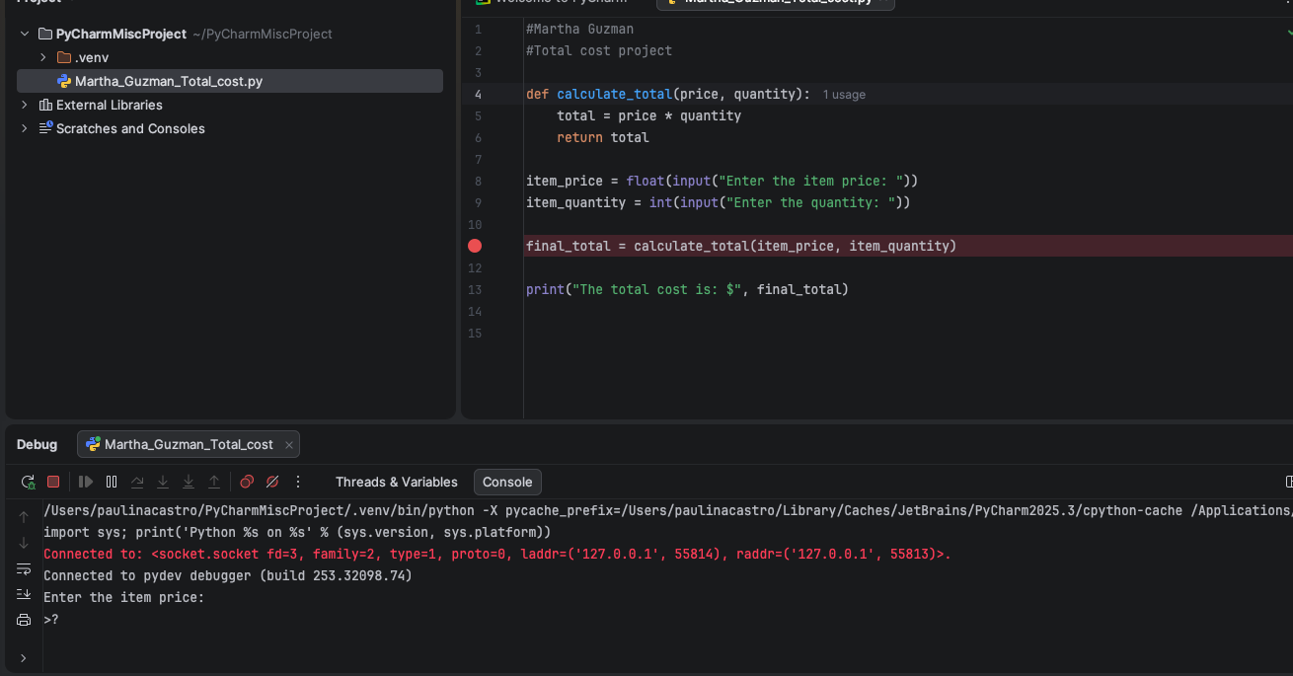

Screenshot #2 – inside calculate total
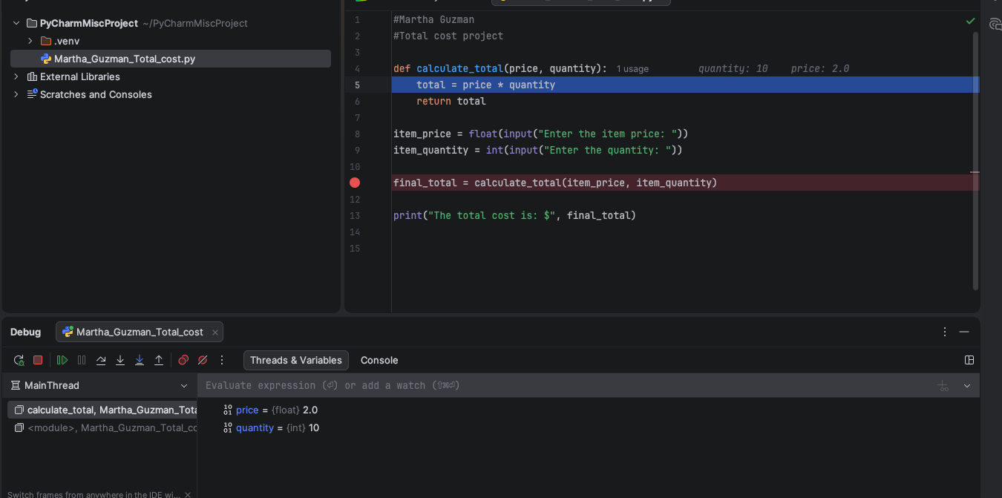

Screenshot #3 – after total price * quantity
